**Lab – 16: To activate the Azure Rights Management service.**

**Objective:** The objective of this lab is –

* To activate the Azure Rights Management service.

When the Azure Rights Management service is activated, you can protect your organization's most sensitive documents and emails, and track how protected documents are used when you share them with others. There are different ways that you can activate protection, which include using Windows PowerShell, and using the admin portals.

**Prerequisite:** EMS Enterprise Mobility + Security E5.

**Steps:**

1. Sign in to your Azure Portal, by using the link - **https://portal.azure.com/**. Enter your credentials and click Sign In.

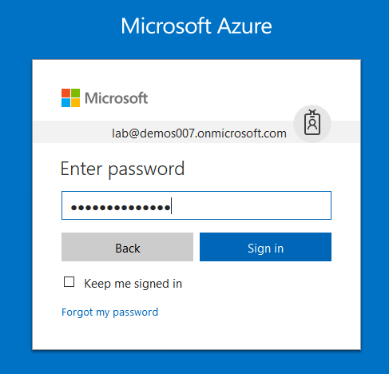

1. Microsoft Azure AD Dashboard will open.

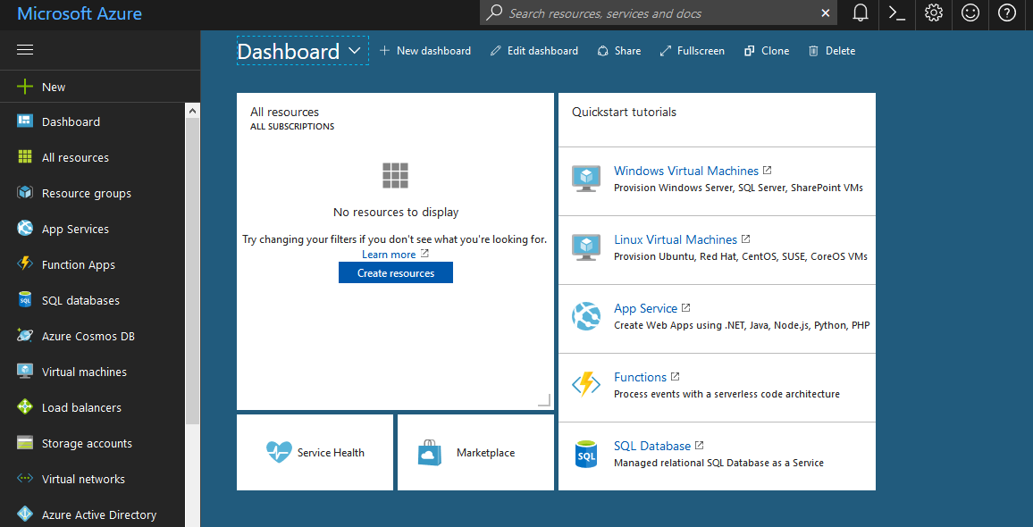

1. On the hub menu, click **New**, and then, from the **MARKETPLACE** list, select **Security + Identity**.

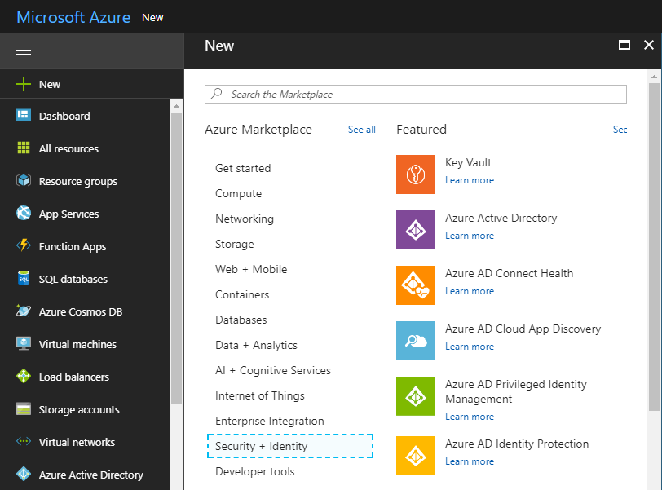

1. On the **Security + Identify** blade, from the FEATURED APPS list, select **Azure Information Protection**. Then, on the Azure Information Protection blade, click **Create**.

This action creates the Azure Information Protection blade so that the next time you sign in to the portal, you can select the service from the hub More services list.

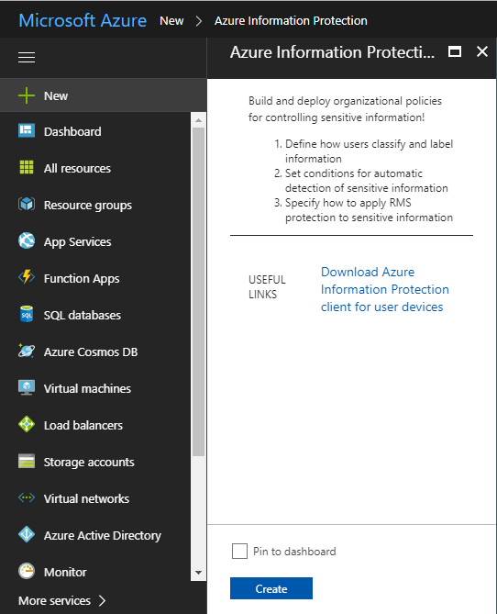

1. So, the Azure Information Protection Service is activated. And, a Azure Information Protection **Created Successfully** notification will be shown.
2. Now, Azure Rights Management service is activated and you can apply RMS protection to sensitive information.